**Data Retrieval:**

**we have greater than 5000 rows every sample has this features**

* Title
* URL
* Score
* Author
* comments
* Text
* post flair
* top comments
* comments score
* category

**features description**

1. Title: brief summary or a headline that encapsulates the content or theme of the post.
2. URL: This refers to the web address of the Reddit post.
3. Score: the score of a post
4. Author: This is the username of the person
5. Text: This is the main body of the post. Depending on the type of post,discuss with
6. Category: stocks, investing, trading , Cryptocurrencies , StocksAndTrading and mutual funds
7. Post Flair: A flair on Reddit is a tag or label of post 'Read the wiki', 'Company Question', Company Discussion
8. Top Comments :top five comments that have score
9. Comments Score :score of every comment

**questions count :**

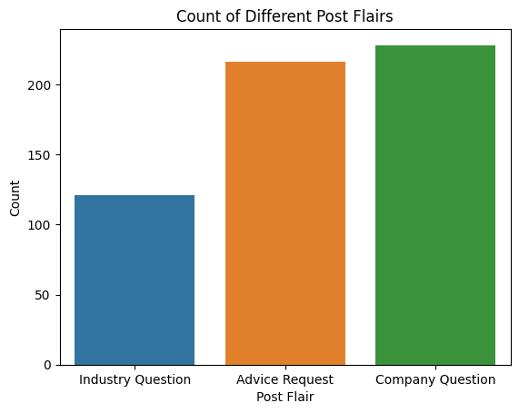

**category counts :**

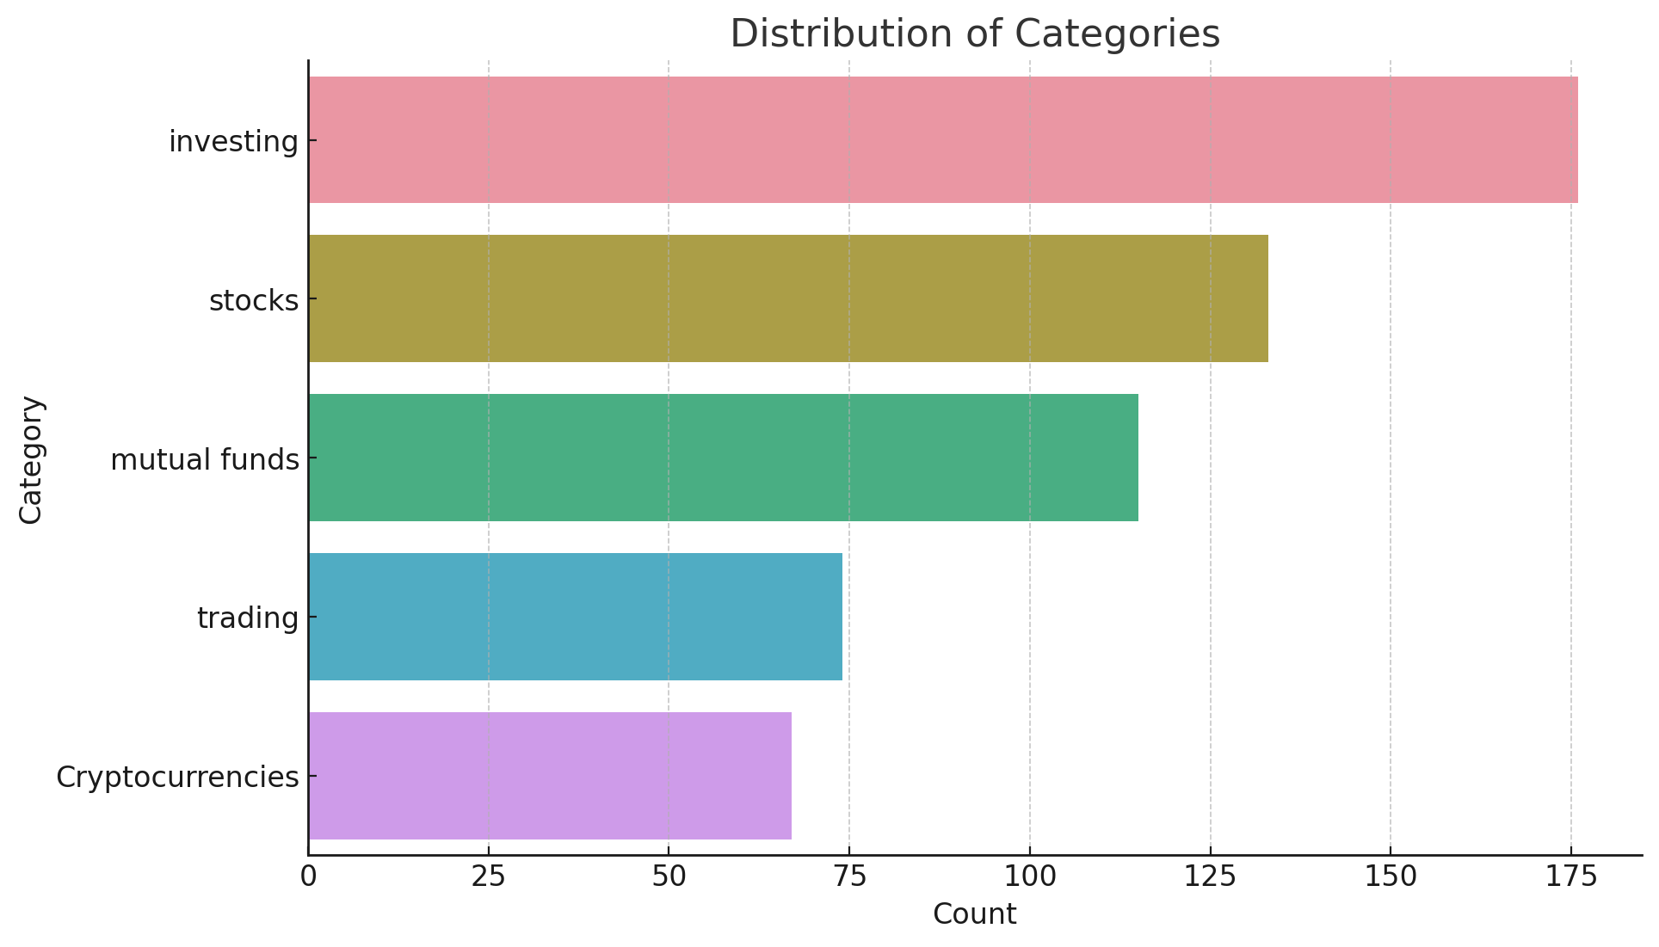

**top 10 questions:**

* Title: What’s the one stock you’re immediately buying if we have a crash?
  + Post Flair: Company Question
  + Category: Stocks
* Title: How bad of an idea is it to spend 50% of my net worth on a house?
  + Post Flair: Advice Request
  + Category: Investing
* Title: Which companies’ products do you use so much that you’d buy their stock?
  + Post Flair: Company Question
  + Category: Stocks
* Title: Which EV would you invest $1000 into right now and why?
  + Post Flair: Company Question
  + Category: Stocks
* Title: Sell or Hold $AAPL?
  + Post Flair: Company Question
  + Category: Stocks
* Title: State of the economy in the US?
  + Post Flair: Industry Question
  + Category: Stocks

Title: Wall Street firms block client access to new stock funds?

* + Post Flair: Industry Question
  + Category: Investing
* Title: Which stock is going to be the Carvana of 2024?
  + Post Flair: Company Question
  + Category: Stocks
* Title: Is compounding $2000 @ 5% weekly to $50M possible?
  + Post Flair: Company Question
  + Category: Trading
* Title: Have you ever started investing around a market high and still did well?
  + Post Flair: Industry Question
  + Category: Stocks